NATIONAL INSTITUTE OF TECHNOLOGY SURATHKAL

IT-254 WTA Lab

Server Side Programming - Using MongoDB

Submitted By-
Akshay B Bistagond
191EC203
Develop an online library website for your department. Design an admin page where the
admin can list, add, remove, update books available in the library. Consider details such
as: book title, author name, edition, subject, number of copies available.
● The admin must make a list of books and add it to the online library.
● Admin must be able to retrieve all the books in the library.
● Admin must be able to search and list the books based on author as well as
subject. Example: Web technologies must display a list of Web technologies
related books.
● Admin must be able to delete any book.
● Admin must be able to update the details of any book.
It is required to follow the Model View and Controller approach for this assignment. Make an appealing frontend for user interaction

Pages:

Home page:
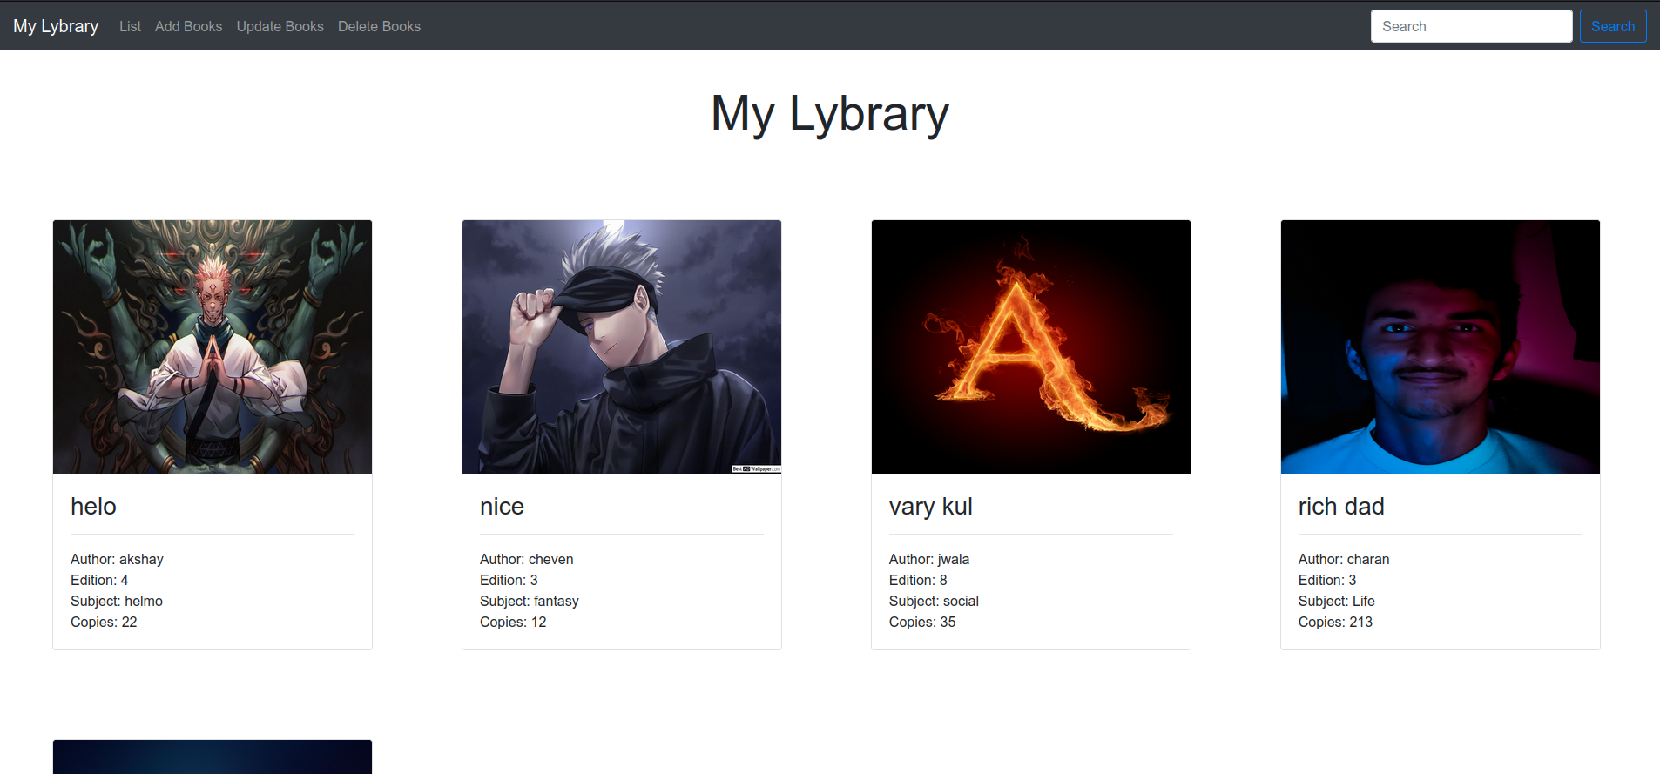

Add Book Page:
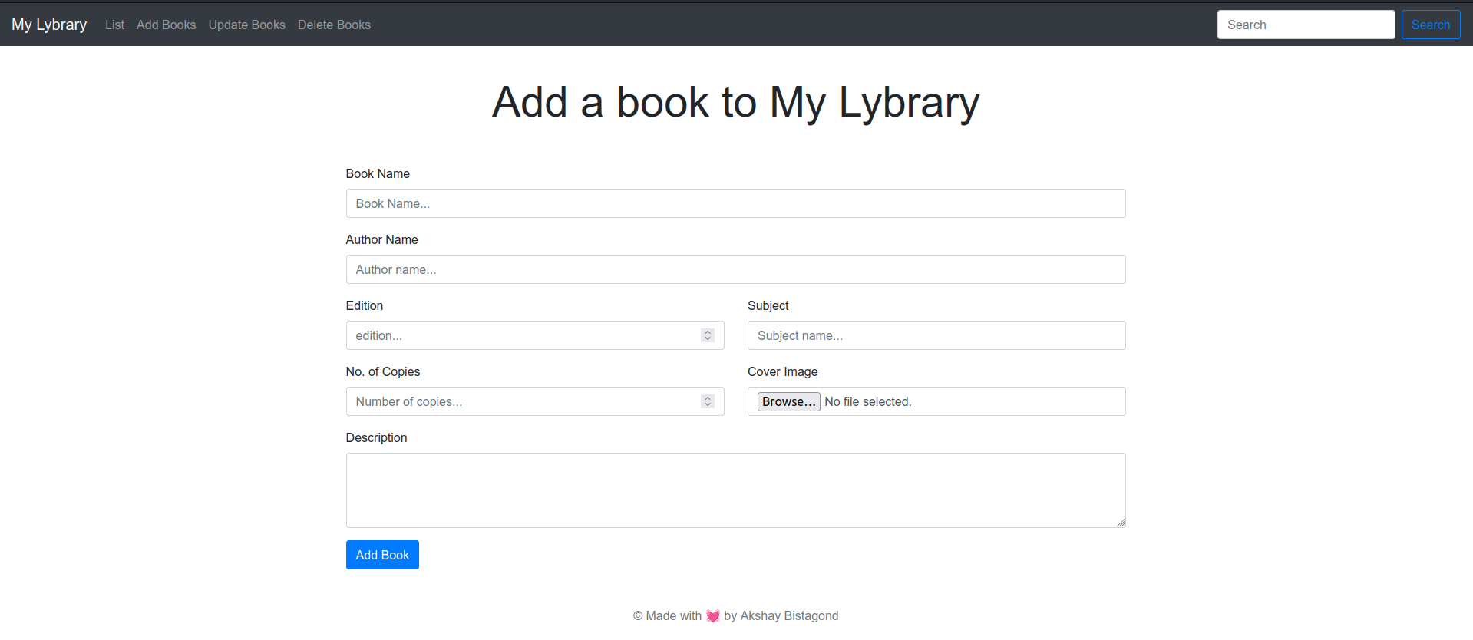

Database Schema to Store book details:-

